Document Number | RP1
Document Title | Billing
Department Ownership | Reception
Document Type | Procedure
Department Owner | Alysia Harper and Angela Di Pardo
Document Author | Alysia Harper and Angela Di Pardo
Last Edited By | Derrick Chan | Lasted Edited On | 07/04/2015

Purpose

The purpose of this procedure is to demonstrate the appropriate procedure to Bill a patient’s appointment.

Scope

For staff that are at the Health screening reception

Reference Documents

Definitions

Flowcharts (Other Images)

Procedures

Once the appointment has occurred it will need to be billed in Genie within 24hours of the appointment occurring. The appointments are usually billed by the exercise physiologist whom completes the medical, however in some cases reception may need to do so.

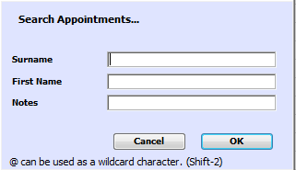
- First you will need to find the patients appointment in genie by pushing “CRTL + F” on your keyboard. This will bring up a window in which you will need to type the patients details to bring up there file.

- Select the correct patient making sure the date of birth and name is the correct. This will then give you the option to select the appointment date the patient attended.
NOTE: MAKE SURE THAT THE CORRECT APPOINTMENT DATE IS SELECTED.

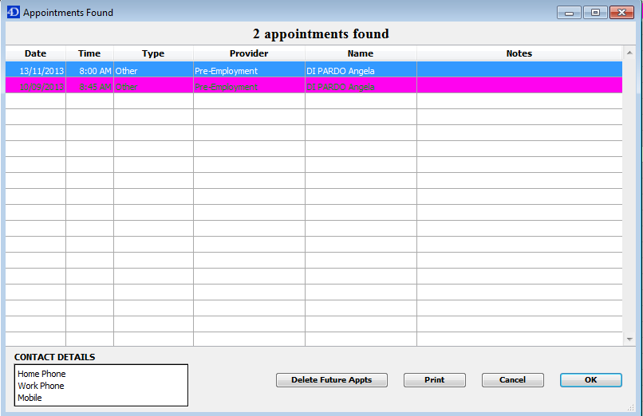

- Once you have selected the correct appointment you need to bill Genie will bring you to the exact date on the appointments list.

- Select the patient’s name so that a black box appears around the patient’s name. You then need to ensure that all the patient’s details have been entered into Genie correctly, such as personal details, employer and PO number. This can be checked by clicking on the blonde man.
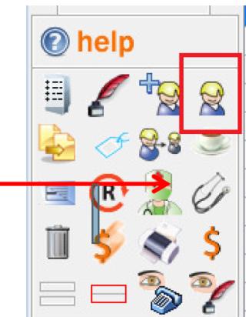

STEP 5.

- Select the Stethoscope icon which is found in the panel on the left hand side of the screen. When the stethoscope is clicked, a pop-up window will appear (see below). When this screen appears, you then need to click the Save button in the top right hand corner.
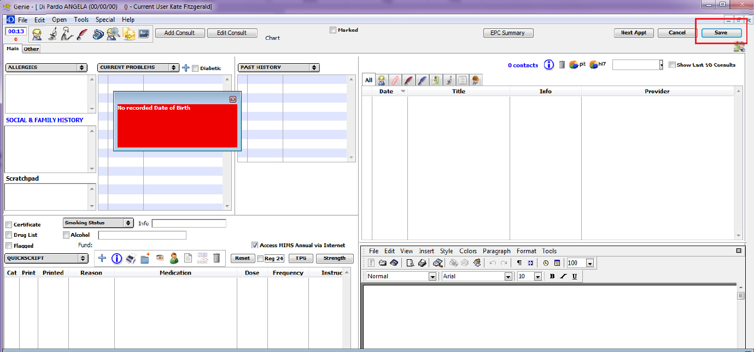
- Once saved is clicked, another pop-up window will appear (see below). This is where the billing codes are to be entered. The codes are in descending alphabetical order. The exercise physiologist will enter the codes once they have completed the assessments. It is then receptions job to double check the codes before sending the results to the company and add anything if necessary such as GCMS or chest x-rays etc.
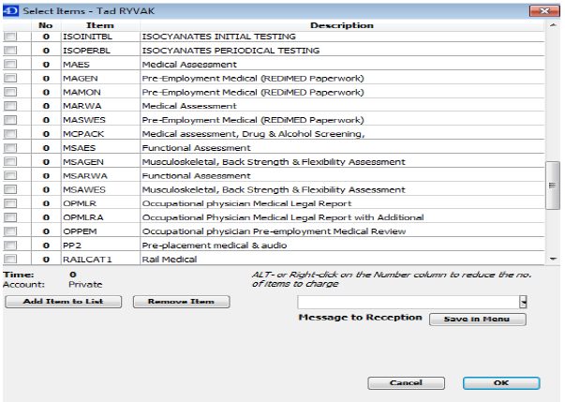

- Check the booking form in the patient’s file for what needs to be billed.
NOTE: If the patient has done more than one DAS or has had a DAS come back as too dilute, please make sure that ALL these items are billed correctly. Below is a general list for the most common assessments, as you can see the codes correspond alphabetically with the description of the assessment.
BILLING | CODES
Billing Code: | Description:
PMAUDIO | Audiometric Assessment
PMDAS | Drug and Alcohol Test
PMECG | ECG Examination
PMMA | Medical Assessment
PMMSA | Musculoskeletal Assessment
PMSPIRO | Spirometry Assessment
PMSYNCAN | Synthetic Cannabinoid Test

- When you have found which code needs to be billed, click on the box to the left of the code, when clicked a little tick should appear in the box. Please double check that a tick is in the box that you have clicked. If any items are missed, the companies will not be billed for them.

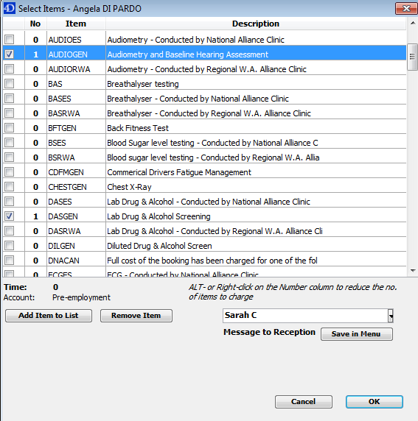

- Once all items are billed and double checked you then need entre your name in the memo box (as above) and then click OK.

- After the appointment has been billed and the results have been linked to the patients file in genie (follow linking procedure) the accounts team will be able to produce the invoice to supply to the company.

Appendices

